**Introduction**

This document presents the Requirements Specification and Analysis (RSA) for the integrated University Accounting System and Human Resources (HR) Management System, essential components of the institution's administrative and financial infrastructure. Through this analysis, we outline the crucial functionalities, user-oriented features, and security considerations that will shape the development of these systems, ensuring seamless management of financial transactions, payments, budgeting, reporting, as well as HR functions like employee information, recruitment, payroll, performance, and development within the university's operational framework.

**Purpose of the RSA Document:**

The primary purpose of this RSA document is to provide a clear and comprehensive understanding of the requirements and specifications that govern the design, development, and deployment of both the university accounting system and the Human Resources (HR) Management System. By documenting these requirements in detail, the document serves as a reference point for developers, stakeholders, and project managers, ensuring that the final systems meet the expectations of both users and the university administration. This document facilitates effective communication and alignment among all parties involved in the project, guaranteeing that the integrated systems cater to the university's financial and HR management needs seamlessly and cohesively.

**Objectives of the RSA Document:**

* Clear Documentation of Requirements:
* Clearly define the functional requirements of the university accounting system.
* Document the technical specifications needed to implement the system's features.
* Outline the essential functionalities and technical requirements of the HR management system.
* Alignment with Security Goals:
* Ensure that the design and development of both systems prioritize data security.
* Address authentication, authorization, data encryption, and access controls for both financial and HR data.
* Data Confidentiality, Integrity, and Availability:
* Guarantee the confidentiality of sensitive financial and HR data, preventing unauthorized access.
* Maintain data integrity to ensure accuracy and reliability in financial transactions and HR operations.
* Ensure the availability of both systems for users whenever needed.
* Efficient Financial and HR Processes:
* Streamline financial processes, enabling students, staff, and administrators to perform transactions smoothly.
* Provide automated features for payments, agreements, reporting, employee information management, and HR processes.
* Scalability and Adaptability:
* Design both systems with scalability to accommodate future growth and evolving requirements.
* Ensure that both systems are adaptable to changes in financial policies, HR regulations, and workforce dynamics.
* User-Centric Design:
* Create user-friendly interfaces that are intuitive for staff, students, and administrators to use in both financial and HR contexts.
* Enhance user experience by providing clear workflows and instructions for both systems.
* Stakeholder Collaboration:
* Facilitate effective communication between stakeholders, developers, and project managers for both systems.
* Enable stakeholders to review and provide feedback on the features and functionalities of both the university accounting system and the HR management system.

**Scope:**

**The features/services that will be included in the applications:**

1. Login:

* employee

Must have a username and password in order to log in to the system employee if authenticated will be directed into if(employee == accountant) employee will be directed into accountant dashboard else will be directed into HR dashboard

1. The accountant’s duties are:

* Receive money from students

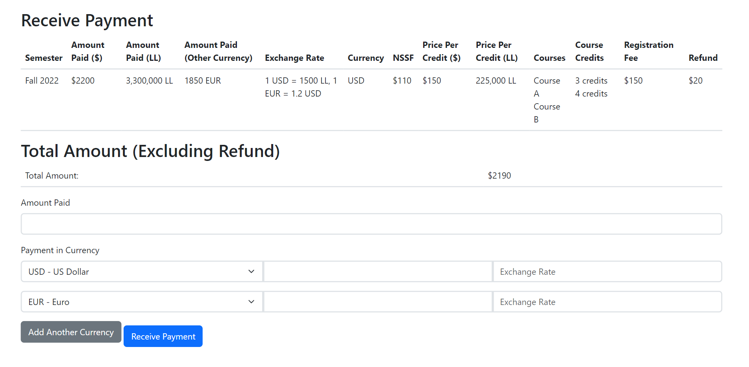

* Receive money from donors

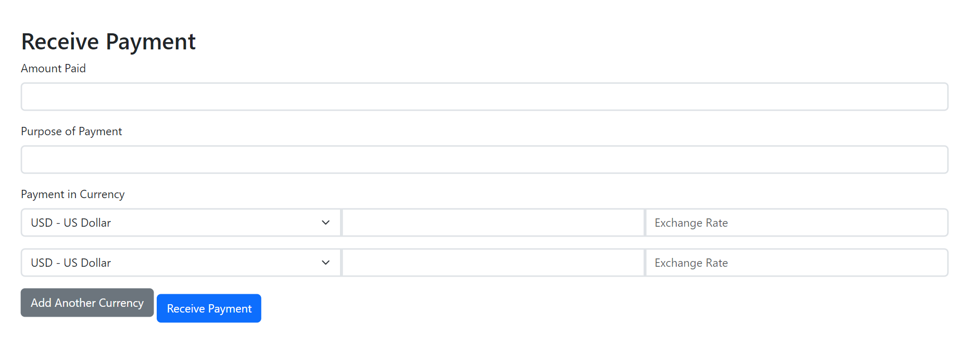

* Application form to fill (mention that this be done in the student affair office)
* Financial statement

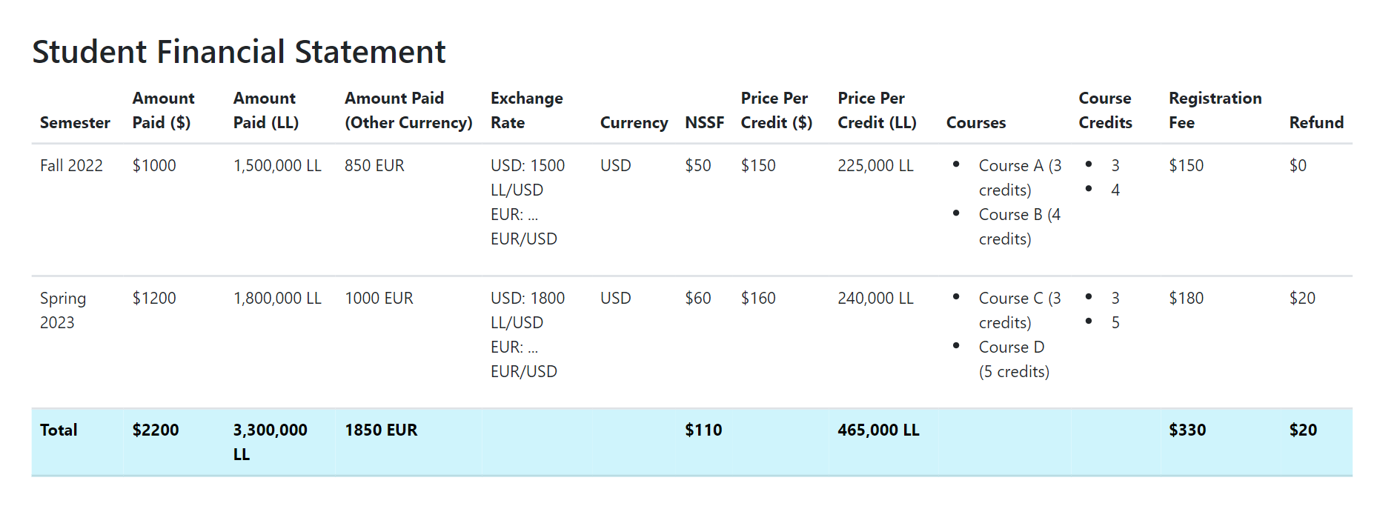

* Financial agreement

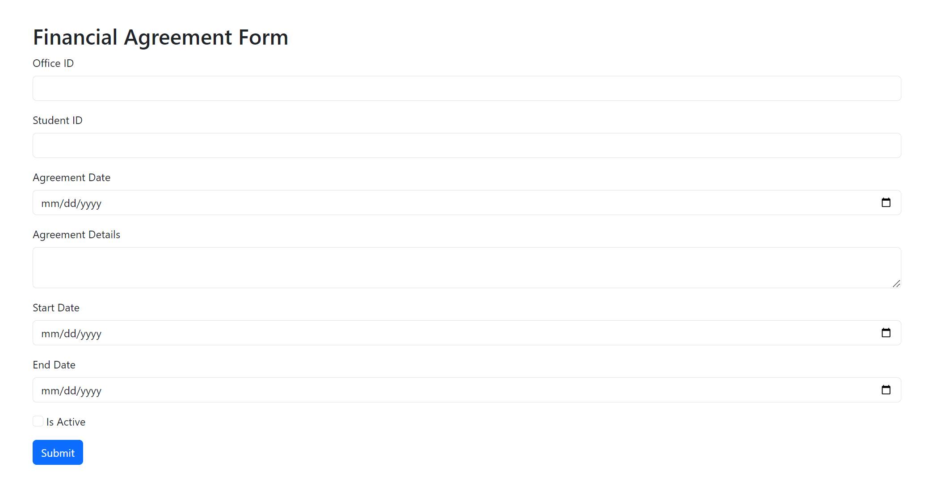

* Pays the salary

**Overview:**

Human Resources:

* The Human Resources Department at our University plays a crucial and impactful role in realizing the institution's strategic objectives. With the responsibility of managing our human capital the HR Department is instrumental in driving our success.
* The HR Department is entrusted with a range of vital operations aimed at cultivating a high-caliber workforce equipped with the essential skills and knowledge to fulfill the University's strategic aspirations. These operations encompass the entire employee lifecycle, including recruitment, performance assessment, and training initiatives. Additionally, the department takes on the pivotal task of overseeing matters pertaining to both academic and administrative staff members. This encompasses matters like compensation, benefits, and allowances, while also orchestrating work schedules and leave arrangements.
* A central tenet of the HR Department's mission is to create a supportive and empowering environment for all University employees. By offering assistance and guidance, the department fosters a positive atmosphere that not only drives productivity but also encourages excellence in all professional endeavors.
* In essence, the HR Department is the backbone of our University's progress, ensuring that we attract, develop, and retain exceptional individuals who contribute to our collective achievements. Through its strategic operations, the HR Department propels us towards a future marked by accomplishment and distinction.

Accounting:

* The Accounting Office at our University serves as a pivotal hub for maintaining the institution's financial integrity and operational effectiveness. With the critical responsibility of managing financial transactions and records, the Accounting Office plays an essential role in safeguarding the university's fiscal health.
* The Accounting Office is tasked with a range of fundamental functions aimed at ensuring accurate financial tracking and reporting, which form the bedrock of informed decision-making. These responsibilities encompass transaction management, expense monitoring, payment processing, budget management, and comprehensive financial reporting.
* Through meticulous transaction management, the Accounting Office empowers authorized personnel to efficiently handle income, expenses, and transfers. Its robust financial monitoring capabilities provide real-time insights into budget utilization, expenditure analysis, and the creation of diverse financial reports including balance sheets and income statements.
* The Accounting Office places a premium on security and compliance, meticulously maintaining an audit trail to ensure adherence to financial regulations and to protect sensitive financial data.
* In tandem with the Human Resources Department, the Accounting Office forms a unified approach to institutional advancement. By seamlessly integrating financial management and human resources administration, these interconnected systems drive the university forward, ensuring financial stability, excellence, and collective success.

**Static information:**

Human Resources:

* Polices:
* The Human Resources office is responsible for planning and managing the non-academic recruitment process within the university.
* Employees' intention to continue working is surveyed annually.
* The new employee is appointed by the university president based on the recommendation of the Vice President responsible for the relevant department.
* The employee is granted an initial salary according to the appropriate category and rank for their job position, based on the university's salary scale.
* If the employee's years of experience exceed the required number for the position, their experience is equated to the salary scale, as deemed suitable by the university administration.
* The employee undergoes a probation period lasting three months, starting from the date of commencing work.
* The Vice President responsible for the relevant department forms the recruitment committee.
* The recruitment committee assumes the following tasks:
* Defining the tasks and qualifications required for the job position.
* Establishing the criteria for employee selection.
* Determining the types of tests and assigning responsible parties for their creation.
* Conducting job interviews.
* Selecting the best candidate from among the applicants.
* Recommending the hiring of qualified candidates to the university president.
* Setting the announcement period and final deadline for applications.
* Determining appropriate advertising methods.

Accounting:

* Scholarships:

1. **Baccalaureate Scholarship:**

Based on high averages in official Lebanese BACC II degree exams.

Discount Rates:

14 – 14.99: 10%

15 – 15.99: 20%

16 – 17.99: 30%

18 and above: 100%

Continuity Conditions: Maintain a certain CGPA in consecutive semesters.

1. **Scholarships for Academic Excellence:**

Outstanding students with high CGPA who completed at least 15 credits.

Discount Rates:

3.50 – 3.74: 20%

3.75 – 4: 30%

1. **Social Scholarships:**

50% scholarships for orphans under 21 years old.

Discount rates based on limited financial capacity, ranging from 5% to 45%.

1. **Special Scholarships:**

40% scholarship for graduates, employees of Al Mabarrat Association institution, and their children.

Educational scholarships for institutions with agreements.

1. **Student Support Fund Scholarship:**

Provides study fee coverage through soft loans for indigent students.

Loan repayment terms are determined based on graduation and employment.

1. **TOMOOH Scholarship:**

Students facing difficult economic circumstances with a minimum average of 12/20 in the final three years of secondary education.

Offers scholarships from 50% to 100% based on social and academic factors.

Continuation Conditions: Maintain CGPA, adhere to student code of conduct, and complete graduation requirements in three years.

### Tuition FEES:

* Tuition Fee - BS in Computer Science (Per Credit): $25 + 750,000 L.L per credit
* Tuition Fee - BS in Business, Media, and Education (Per Credit): $20 + 630,000 L.L
* Tuition Fee - TD (Per Credit): $30 + 1,120,000 L.L per credit
* Registration Fee for Fall and Spring Semesters: $150
* Registration Fee for Summer Semester: $100
* Registration Application Fee and Entrance Examination Fees: $50
* NSSF: 4,000,000 L.L

Policies:

* Students should know the financial implications of their chosen procedures and abide by the University's financial regulations.
* Application fees, placement test fees, and registration fees are non-refundable.
* Students face a penalty fee if they fail to register within the designated period.
* Withdrawal in the second or third week of a semester requires payment of 30% of the course's credit cost.
* Withdrawal after the third week necessitates full payment of the course's credit cost.
* Tuition fees should be paid as scheduled in the University Calendar. Failing that, a fine is incurred if no prior financial agreement was made.
* Tuitions are paid in cash and in Lebanese Lira based on the official exchange rate.
* Tuition payments are divided into four installments within specific periods.
* First Payment: Within two weeks from the semester's start
* Second Payment: Within six weeks from the semester's start
* Third Payment: Within ten weeks from the semester's start
* Fourth Payment: Within fourteen weeks from the semester's start

Application for Financial Statement:

* Students need to fill an application form at the Cashier to obtain a financial statement.
* If required for an official body, an attached application form is necessary.
* First-time applicants during a semester do not need to pay any fees.
* A financial statement can be obtained after full tuition and fee payment.

Contact Information:

Students can reach the Accounting Office or Cashier through:

* Visiting during working hours
* Calling specified phone numbers
* Sending an email to the provided address

**REQUIREMENTS:**

STUDENTS-STAFF:

* Implement a login verification process to enhance the security of student payments.
* Display clear error messages to guide users effectively when issues arise.
* Enable users to securely log out from their accounts, ensuring their privacy and data protection.
* Access a dedicated section to view your payment history and transaction details conveniently like the following:

1. Show potential refunds for transactions

2. Review payments that have been successfully processed

3. Check the remaining balance on your account.

1. Access records from previous semesters for your reference.

* Allow staff to efficiently update payment records when students make payments or request refunds, ensuring accurate and up-to-date financial information.
* Students can conveniently make payments for various services and fees, ensuring a streamlined and hassle-free transaction process.
* Initiating a refund process for students who have dropped out of courses or withdrew from a semester, ensuring fair reimbursement of fees associated with deleted courses.
* Easily request a comprehensive financial statement that outlines your transactions, expenses, and payments, providing a clear overview of your financial activity.
* Easily download a comprehensive payment list, providing you with a convenient and organized record of all financial transactions and payments made.
* Students can schedule an appointment with the accounting department to discuss financial matters or concerns.
* student initiates the process of applying for financial aid to seek assistance with covering educational expenses and the staff evaluates and decides whether to accept or reject the applications for financial aid based on the provided information and eligibility criteria.
* financial statement VS download payments :
* The financial statement is paid version which is detailed and includes comprehensive information and insights compared to the standard version which is download payments

DONOR-STAFF:

* Donors have the ability to review the payments they have made
* Verify the remaining balance to keep track of the funds available for future expenses or transactions.
* Initiate a payment for fees, services, or other financial obligations using one of the provided payment methods.
* Submit a request for financial certification to obtain an official document verifying your financial status or ability to meet certain financial requirements.
* Collaborate with staff to establish customized payment plans, allowing for more flexible and manageable installment-based payments.
* Arrange a specific date and time for an appointment to discuss a particular matter or seek assistance.
* Monitor and assess the effects and outcomes of donations, gauging how they contribute to the intended goals and initiatives.

Cashier:

* Handles financial interactions with students, managing payment collection, fee processing, and issuing receipts.
* Handles the process of paying salaries to university employees, making sure payments are correct and delivered on time.
* Administers event-related financial activities, including registration fees and participant payments.
* Manages various financial transactions, such as handling reimbursements, petty cash, and small expenses.
* Serves as a go-to person for internal financial questions, helping students and employees with their inquiries and providing support on financial matters within the university.

Accounting Office:

* Ensures adherence to the university's financial policies and regulations, maintaining accuracy and integrity in financial operations.
* Manages and updates static financial information, such as price lists and fee structures, to reflect accurate financial details.
* Oversees event payment processes, tracking incoming event-related funds and maintaining accurate records.
* Records payments received from external sources, including donors and partners, and ensures proper categorization.
* Monitors expenses related to facility maintenance, repairs, and services, maintaining clear records of financial transactions.
* Handles payments to vendors and service providers, verifying invoices and maintaining vendor relationships.
* Generates comprehensive financial reports and analyses, providing valuable insights for decision-making and planning.

Recruitment:

* Develops an annual plan in coordination with various administrative office and academic department heads to identify university staffing needs and work towards fulfilling them.
* Participates as a member of the committee responsible for selecting administrative staff, conducting necessary assessments to identify competencies aligned with the university's requirements.
* Establishes a database containing all necessary information about job applications and CVs for future reference.
* Periodically reviews job descriptions for university employees to assess their alignment with evolving work requirements.
* Prepares and maintains a database of employee information, updating it regularly for reference.
* -inform the candidate employees with the policies of the university,workspace behavior and tips.

Training and Development:

* Conducts a survey of employee training needs in coordination with department heads to create a professional development plan.
* Coordinates communication with specialized entities to offer training programs, monitors their organization and assesses their impact in coordination with department heads for evaluation and effectiveness.
* post up to date training materials of different programs of employee types on the platform.
* manage contracts with other companies
* manage workshops and events .

Performance Evaluation:

* Plans the implementation of performance evaluation processes across departments, track rating and progress of employees.
* Monitors all procedures related to evaluating new employees' performance .

Contracts, Compensation, and Salaries:

* Prepares and renews seasonal and annual employment contracts with employees as needed.
* Monitors the salary, benefits, and incentives system.
* Communicates with the accounting department regarding any changes or updates to employees' financial statuses (grades, allowances, salaries, overtime pay, etc.).
* Offer the employee benefits package having a retirement plan, bonuses, and insurance.

Attendance and Leave:

* + Generates regular reports on employees' compliance with designated work hours and submits them to the Vice President for Administrative and Financial Affairs for follow-up on adherence to the established system.

Employee:

* Employees can ask for vacation and give the correct excuse.
* Employee can admit a request to quit the position.
* Employees can benefit from benefit packages.

Other Tasks:

* + Acts as a bridge of communication between employees and the university administration to ensure smooth operations.
  + Receives employees' feedback on a daily basis and answers their inquiries promptly.
  + Prepares various certificates related to employees (experience, salary, etc.).
  + Undertakes any related tasks as assigned by the direct supervisor.

**USE CASE DIAGRAMS:**

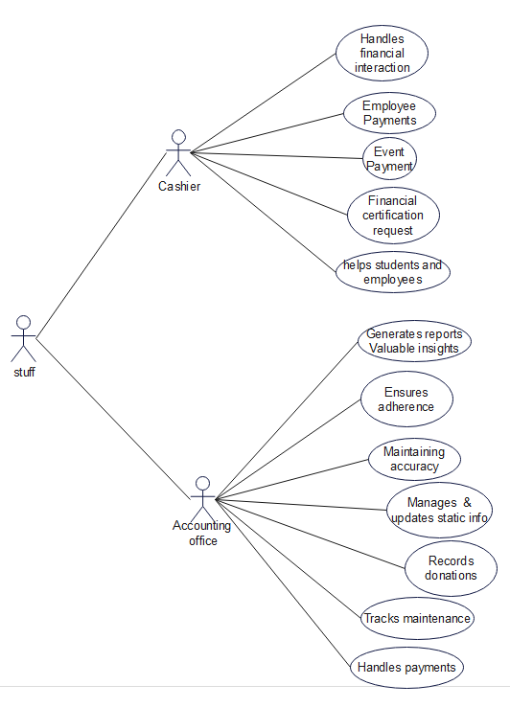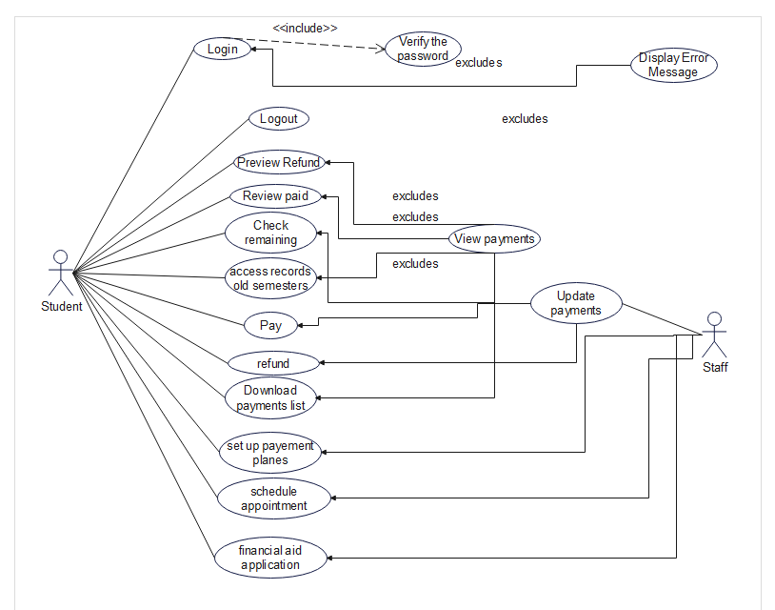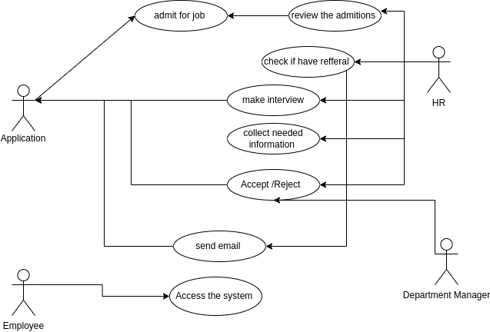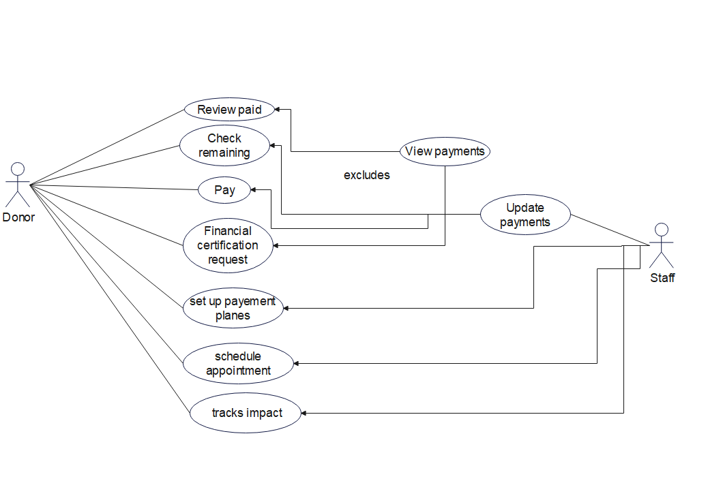

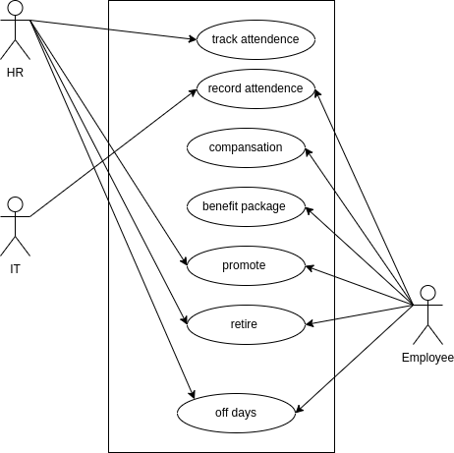

**ER diagram:**

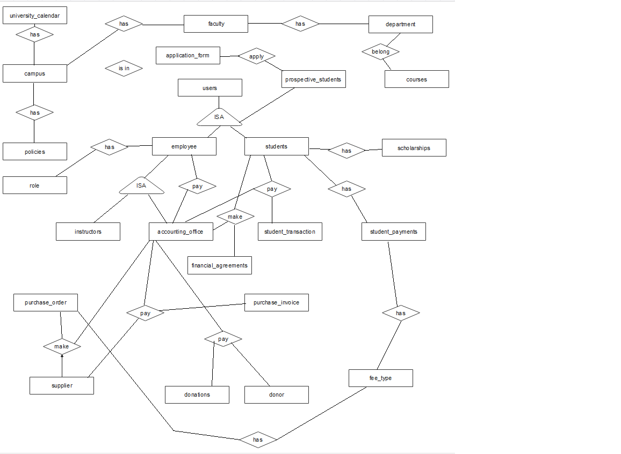

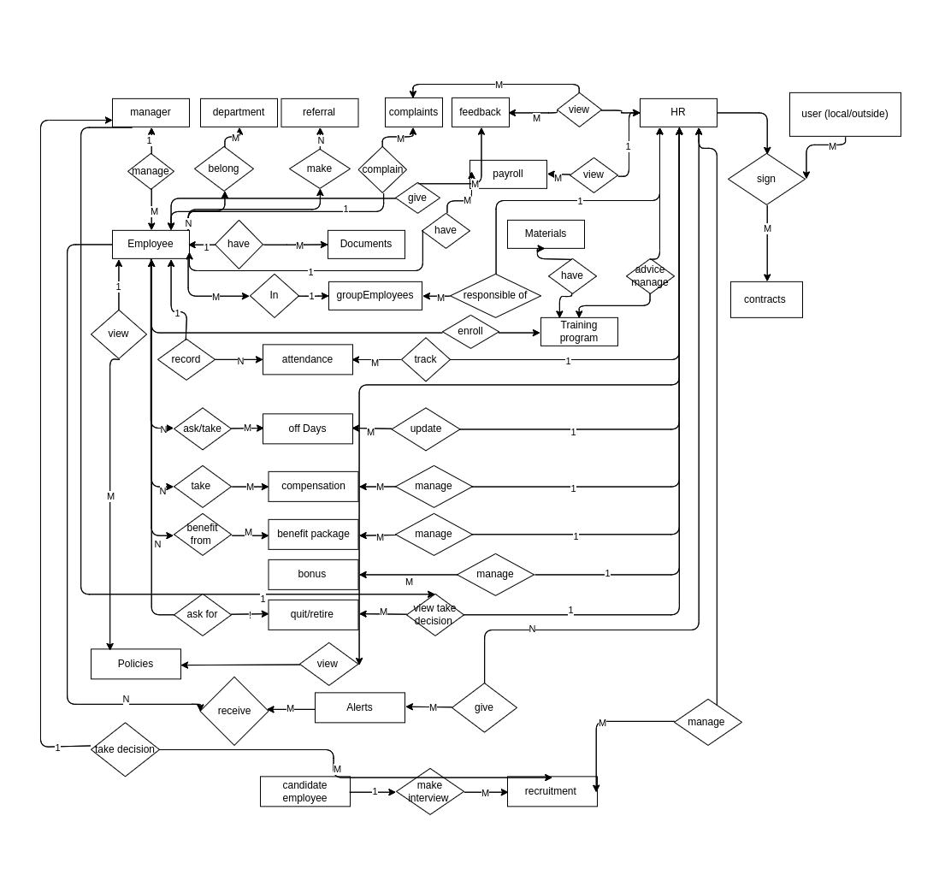

**Database Diagram:**

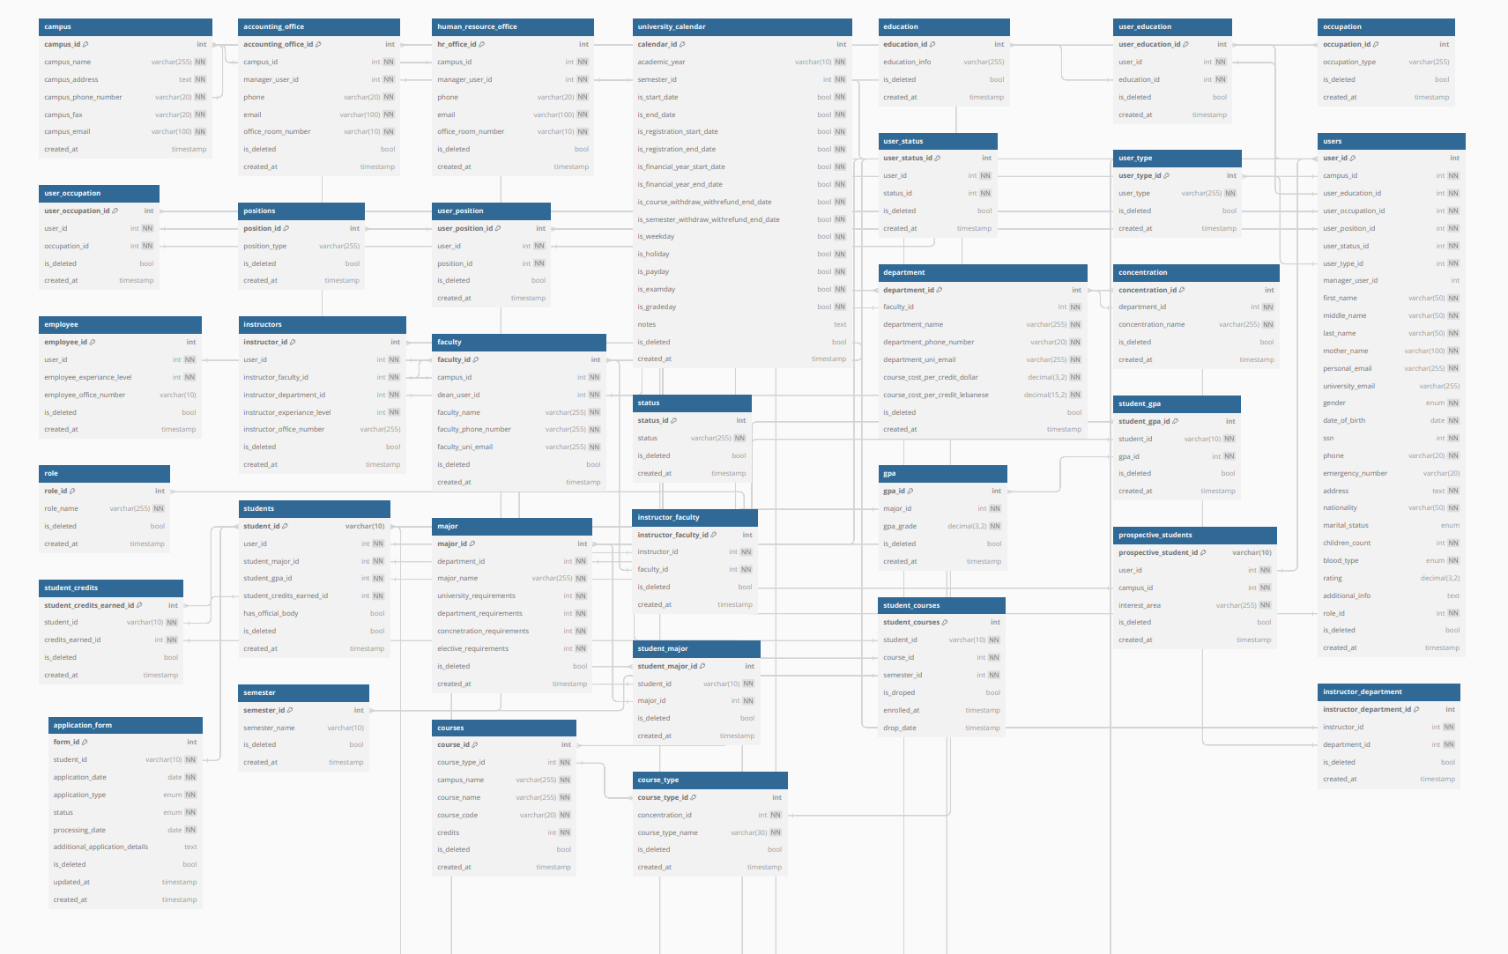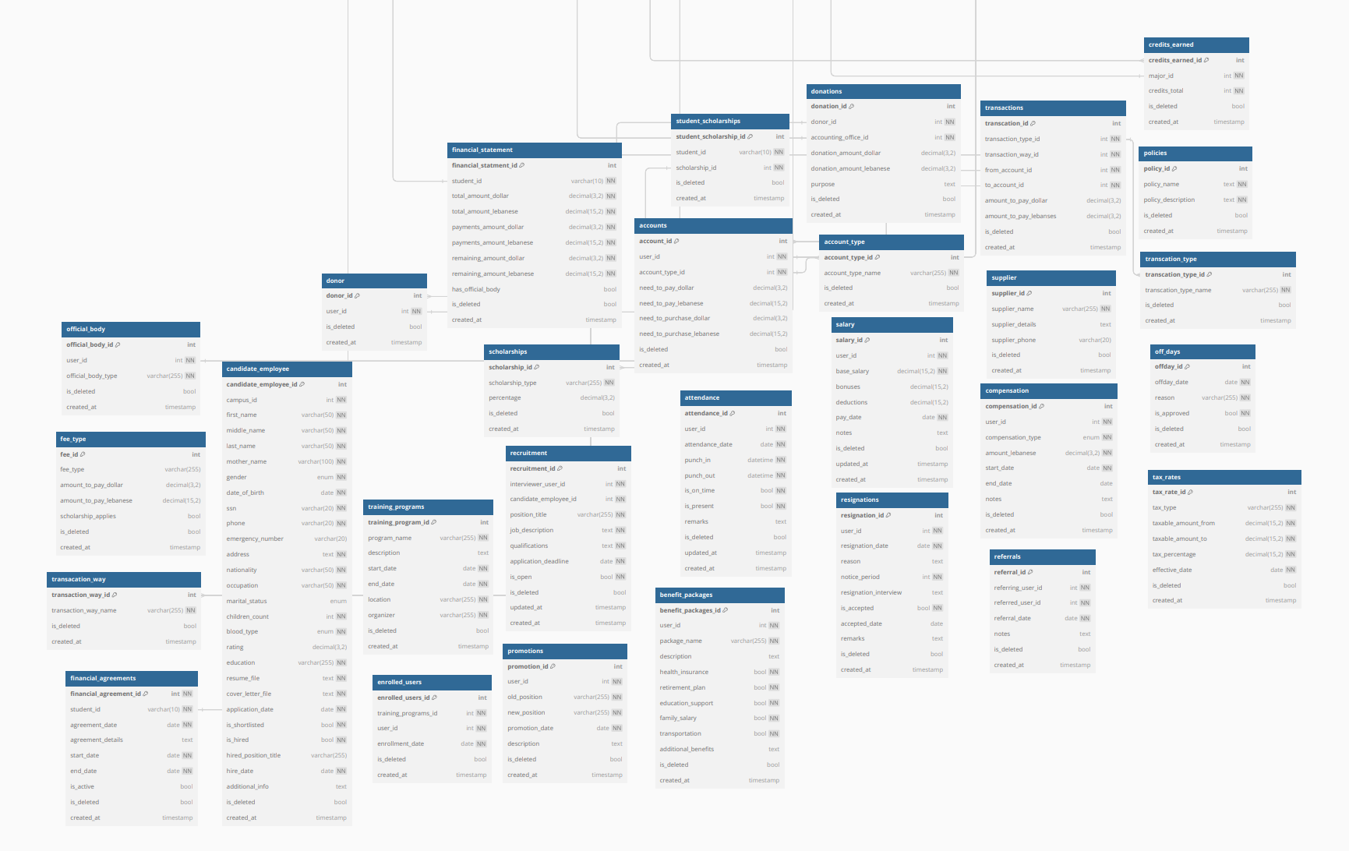

Non-Functional Requirements:

**Security and Privacy:**

Authentication and Authorization:

* User authentication must follow industry best practices, such as password hashing and salting.
* Role-based access control should be implemented to ensure that users have appropriate permissions.

Data Privacy:

* Personal and financial data of users must be encrypted both during transmission and storage.
* Compliance with relevant data protection regulations (e.g., GDPR, HIPAA) is mandatory.

**Usability and User Experience:**

User-Friendly Interface:

* The user interface should be intuitive and easy to navigate for all user roles.
* Clear and concise language should be used for error messages and instructions.

Responsive Design:

* The system's interface should be responsive and compatible with various devices and screen sizes.

**Performance and Scalability:**

Response Time:

* The system should provide fast response times for all user interactions, aiming for less than 2 seconds per action.

Scalability:

* The system architecture should be designed to handle increased user loads during peak times, such as enrollment periods.

**Reliability and Availability:**

System Uptime:

* The system should have at least 99.9% uptime, ensuring minimal downtime for maintenance or updates.

Backup and Recovery:

* Regular automated backups of the database and system configurations should be performed to facilitate data recovery in case of failures.

**Maintainability and Extensibility:**

Code Maintainability:

* Codebase should follow coding standards and best practices to ensure ease of maintenance by the development team.

Modularity:

* The system's architecture should be modular, allowing for easy integration of new features or components.

**Compliance and Regulations:**

Financial Regulations:

* The system must comply with relevant financial regulations and standards applicable to payment processing and financial reporting.

Accessibility:

* The user interface should be designed to meet accessibility standards (e.g., WCAG) to accommodate users with disabilities.

**Performance Testing and Load Handling:**

Load Testing:

* Regular load testing should be conducted to assess the system's performance under different user loads.

Scalability Testing:

* Test the system's ability to scale and handle increasing loads without compromising performance.

**Documentation and Training:**

User Documentation:

* Provide comprehensive user manuals and documentation for each user role to ensure efficient system usage.

Training:

* Offer training sessions for users and staff to familiarize them with the system's features and functionality.

**Integration and Interoperability:**

APIs and Integrations:

* If applicable, provide well-documented APIs to facilitate integration with other university systems.

Browser Compatibility:

* Ensure the system functions correctly across popular web browsers and versions.

**Reporting and Analytics:**

Reporting Performance:

* The generation of financial reports and analytics should be completed within a reasonable time frame.

Data Accuracy:

* Reports and analytics should reflect accurate and up-to-date financial information.